<html>

<head>

<title>htmlEX</title>

<p>KISHORE_RVK</p>

<br/>

</head>

<body>

<h1 align=center>TAJ MAHAL</h1>

<p align=center><img src="Z:\3-1 WebTechLAB\tajmahal.jpg" height=60% width=40% alt="TAJ"/> </p>

<br/>

<br/>

<h2 align=right><strong>____ABCDEFG</strong></h2>

<br/>

X<sub>2</sub>Y<sub>3</sub>

<br/>

X<sup>3</sup>Y<sup>2</sup>Z

<p align=center><font size=20pt color=blue face="arial">welcome to RVRJCCE</font></p>

<div style="font-size:20px; color:green">DIV example</div>

<p>Its an<span style="color:blue; font-weight:bold"> simple example</span>.</p>

<marquee>

<img src="lion.jpg" height=50% width=30% behaviour="slide" direction="down" loop=2/>

</marquee>

<marquee behavior="alternate" direction="right" scrolldelay="100" style="color:red; font-weight:bold">KISHORE_RVK</marquee>

<Table border="6">

<caption>STUDENT LIST</caption>

<tr>

<th>NAME</th>

<th>Regd.No</th>

<th>section</th>

</tr>

<tr>

<td>Ashish</td>

<td>Y19IT014</td>

<td>A</td>

</tr>

<tr>

<td>Kishore</td>

<td>Y19IT015</td>

<td>B</td>

</tr>

<tr>

<td>Teja Srinivas</td>

<td>Y19IT016</td>

<td>A</td>

</tr>

<tr>

<td>Sai kolluri</td>

<td>Y19IT059</td>

<td>B</td>

</tr>

<tr>

<td>Harsha vardhan</td>

<td>Y19IT062</td>

<td>A</td>

</tr>

</Table>

</body>

</html>

KISHORE_RVK

**TAJ MAHAL**

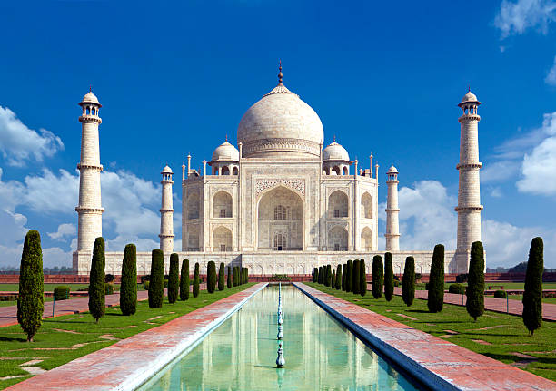

**____ABCDEFG**

X2Y3  
X3Y2Z

welcome to RVRJCCE

DIV example

Its an**simple example**.

 

|  |  |  |
| --- | --- | --- |
| STUDENT LIST | | |
| **NAME** | **Regd.No** | **section** |
| Ashish | Y19IT014 | A |
| Kishore | Y19IT015 | B |
| Teja Srinivas | Y19IT016 | A |
| Sai kolluri | Y19IT059 | B |
| Harsha vardhan | Y19IT062 | A |